**Day 47 DIY**

**DIY Questions:**

Alice is presently employed as an intern in a reputable company, her manager has assigned her some tasks related to repository and GitHub. Help Alice to perform the following tasks.

**Tasks:**

1.Create a remote repository on GitHub.

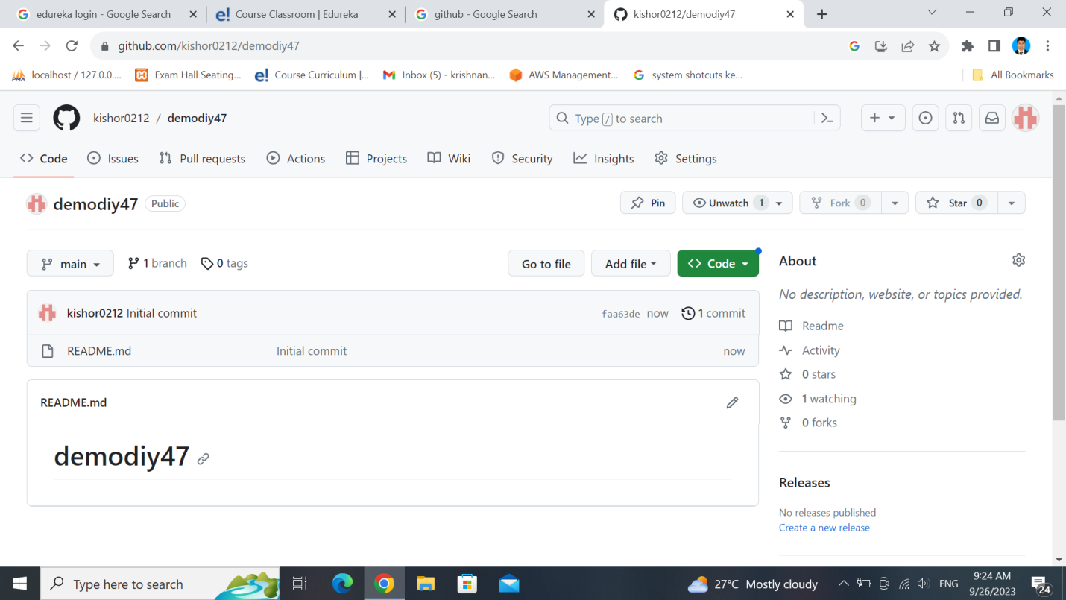

2.Add a file in the main branch in the GitHub repo

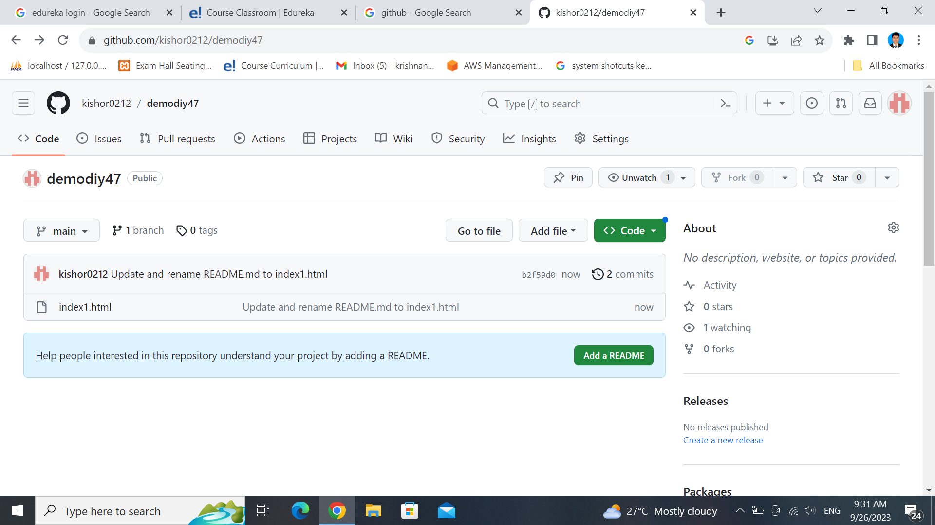

3.Clone the repository to the local server

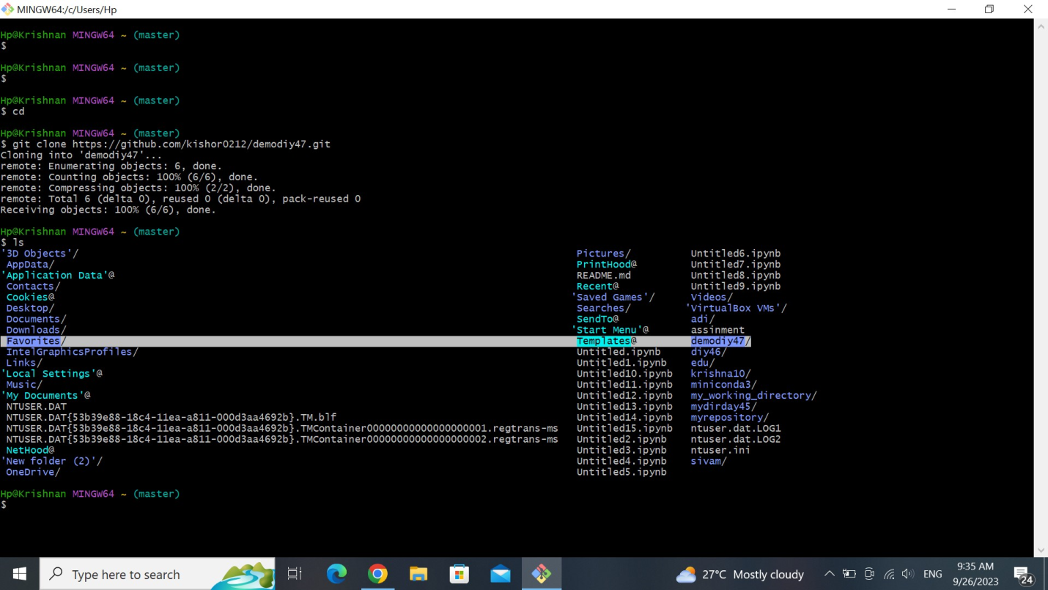

4.Create a new branch with a name feature

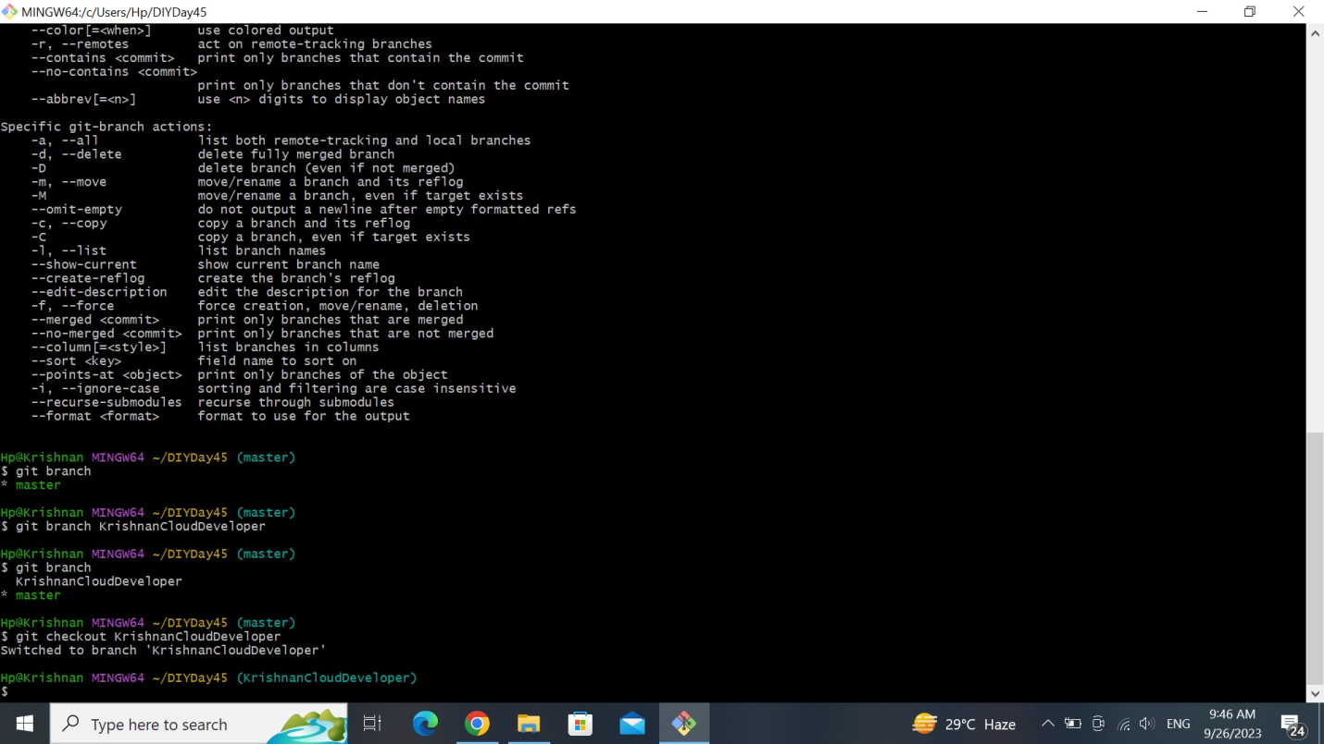

5.Checkout out the branch feature

git checkout feature

6.Add a new file to the branch feature

touch index2.html$ git

commit -m "hi"

7.Push the branch to the remote repository

git push -u https://github.com/kishor0212/demodiy47.git

8.Create a pull request in Github and merge the feature branch with the main branch.

9.Delete the feature branch in the remote repository

10.Delete the feature branch on local repository

